1.Install Node :- So far, we have only run javascript inside a browser. Node allows us to run javascript outside our browser as well

<https://nodejs.org/en/>

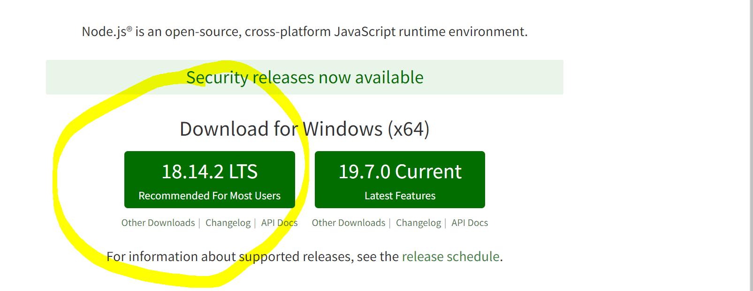

2.Check wether its installed or not open the command prompt in your system

**node –version**

**npm –version**

**3. install expo line tool**

**npm install expo-cli –global**

Expo command line tool or ‘expo-cli’ comes with many libraries and tools already installed which help us in quickly getting started with building react native apps

4. cd Desktop //if its not working then cd Downloads

It will change the directory to desktop so that you can acess the folder easily

5. npx create-expo-app <folder name>(To create a new project)

Eg:- npx create-expo-app weatherApp

6.open the folder in visual studio do the changes and save

7. in command prompt to execute **the npx expo start --tunnel**

This will start your project. It will generate a QR code. You can scan the QR code on an expo client installed on your phone to open the app.

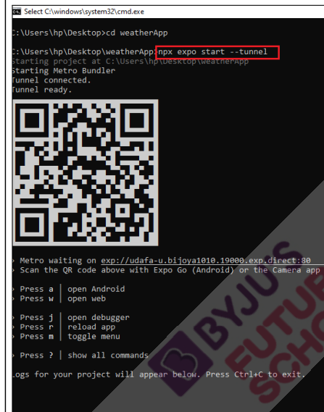

**Scan the qr code on mobile and you will be able to see output**